Sorting & Filtering

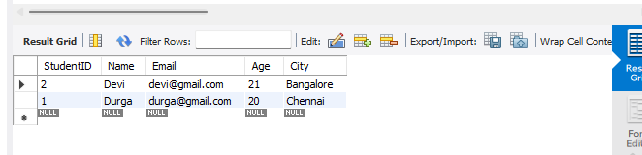

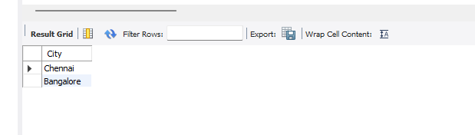

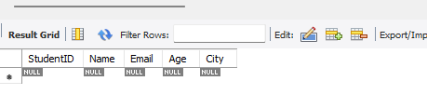

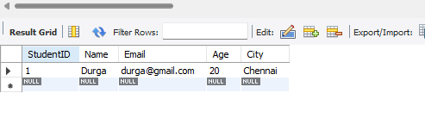

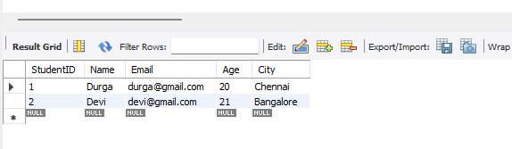

Explanation:
The queries successfully demonstrate sorting, removing duplicates, pattern matching, IN filtering, and BETWEEN filtering on the Students table.
They retrieve records based on different conditions such as Name, City, and Age.

